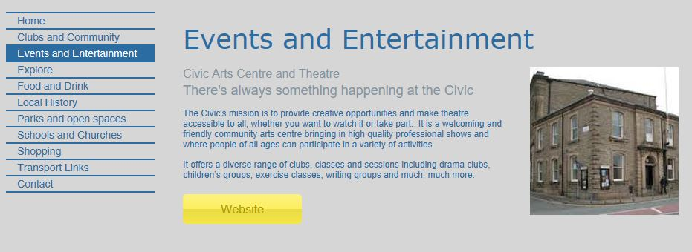
www.thisisoswaldtwistle.co.uk
Example
For inclusion on the website
Name (5 words maximum)
Subtitle (5 words maximum)
Text (50 words maximum)

Link to website or Facebook

Not for inclusion on the website
Contact name
Telephone
Email
Which categories do you think you best fit?

Email a photograph to info@civicartscentre.co.uk use THIS IS OSWALDTWISTLE in the subject line.

